SOFTWARE REQUIREMENTS SPECIFICATION

FOR

**STOCK NEOCORTEX**

**Version: 1.00**

**SUBMITTED TO,**

Department of Computer Engineering

U.V.Patel College of Engineering

Ganpat University

©13012011028 : Aniket Patel

13012011059 : Tirthraj chauhan

Table of Contents

1. Introduction x

1.1 Summary x

1.2 Purpose x

1.3 Scope x

2. Project Work Flows x

2.1 Use case Diagrams x

2.2 Process Flow for each Use case Diagrams / Modules x

3. Functional Requirements x

3.1 Assumptions (Constraints) x

3.2 Details about each Modules / Functions with User Interface x

4. Database Design x

4.1 Entity-Relationship Diagram x

4.2 Table Structures x

5. Non-Functional Requirements x

5.1 Performance x

5.2 Reliability x

5.3 Usability x

6. References x

# Introduction

## Summary

## Stock market prediction is the act of trying to determine the future value of a company stock or other financial instrument traded on a financial exchange. The successful prediction of a stock's future price could yield significant profit. The stock market is not an efficient market. Herding behavior is common among investors, all investors do not get all information at the same time and the time it takes to evaluate information before they act differs between investors.

Many investors do not show rational behavior. Greed and fear are strong feelings and may result in panic sales and stock market bubbles. Hence, to regulate the stock market to obtain maximum profit or achieve a certain objective in general without falling prey to inconsistencies,predicting stock behavior is a pressing requirement.Prediction methodologies fall into two broad categories: fundamental analysis and technical analysis. Fundamental analysis of a business involves analyzing its income statement,financial statements and health, its management and competitive advantages, and its competitors and markets. It is more subjective compared to technical analysis. Fundamental analysis maintains that markets may misprice a security in the short run but that the "correct" price will eventually be reached. Profits can be made by trading the mispriced security and then waiting for the market to recognize its "mistake" and recalculate the security price. On the other hand, Technical Analysis is an approach that uses information of past stock behavior in order to forecast future price movements. Within the technical analysis community there exist several schools with different techniques, but they all have in common that they use price and volume

history. A basic thought is that it takes time before the market reacts upon new information and that pattern often occur in price behavior which makes forecasting possible.

There are several factors that explain why fundamental analysis works how our system give plus support:

1. Most speculators on the market act upon fundamental analysis, so that kind of facts influence stock prices strongly. But all operators do not get this information at the same time. When there are positive news of a company, those acting immediately can buy shares for a lower price than those getting the news later. So we are making graph with news pop-up on on price tag so every one can get news on time and everyone can contribute to move stock price strongly.

2.in this market everybody spend their time to find clue of stock market ,for small number of stocks. all speculators are always trying to find pattern in stock prices or event based price triggering. so we are making system that they can provide algorithm and we set it on system that also check it’s work properly or not and how many prediction is correct so ,other speculators use that verified algorithm.

3. It is more psychological stressing to go against the trend than to follow it. People are herding animals and like to do as others are doing. This is why a rising stock price is a signal in itself that the price will advance even more. Of course one has to be careful with stocks that have been rocketing, because they will often recoil .so we can remove problem of psychological increase in stock market and focusing on news based or fundamental

Hence, we limit our focus to news-graph feature which has time and again proved it supremacy over other methods. There are many tools available to investors using technical analysis but none of them removes entirely the element of chance from investment decisions. Large trading organizations can employ sophisticated computer systems and armies of analysts. We, as students, attempt to employ a simple set of formidable tools to achieve the same result for the benefit of small-time investors who cannot afford to hire experts or buy costly softwares to make their investment decisions.

## Purpose

The purpose of **Software Requirements Specification (SRS)** document is to describe the external behavior of the stock neocortex. Requirements Specification defines and describes the operations, interfaces, performance, and quality assurance requirements of System. The document also describes the nonfunctional requirements such as the user interfaces. It also describes the design constraints that are to be considered when the system is to be designed, and other factors necessary to provide a complete and comprehensive description of the requirements for the software. The Software Requirements Specification (**SRS**) captures the complete software requirements for the system, or a portion of the system. Requirements described in this document are derived from the Vision Document prepared for the DAMS.

## Scope

The Software Requirements Specification captures all the requirements in a single document. The stock neocortex that is to be developed provides the various functionality to make department management easy. The DAMS is supposed to have the following features.

* User can search information about stock
* view our neocortex chart that is provide event points.
* User can also follow links and read full news by clicking on points.
* User can also submit algorithm in way we can understand and put it on system..
* also review the algorithm so other user can trust.

# Project Work Flows

## Use case Diagrams

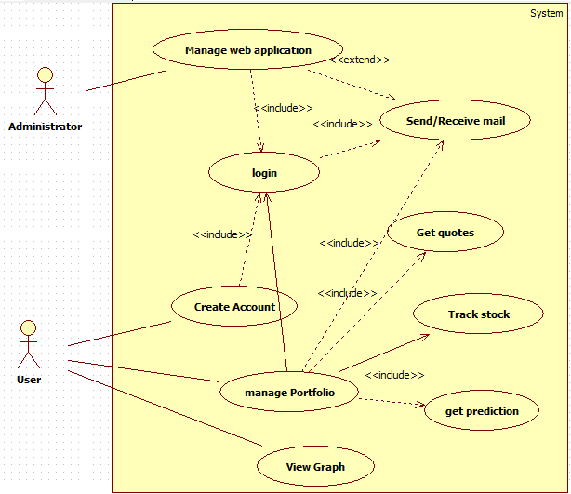

## Process Flow for each Use case Diagrams / Modules

# Functional Requirements

## Assumptions

* The users have sufficient knowledge of Application.
* The users have Internet connection.
* The users know the English language, as the user interface will be provided in English.

## Details about each Modules / Functions with User Interface

### User Interfaces

Will make use of the existing Web Browsers such as Microsoft Internet Explorer or Firefox, Chrome, etc.. The user-interface of the system shall be designed as shown in the user-interface prototypes.

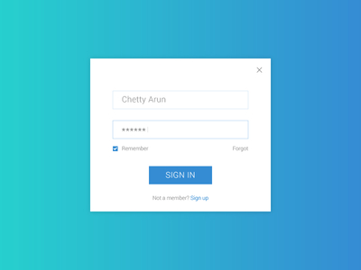

***Figure-1: Login Screen***

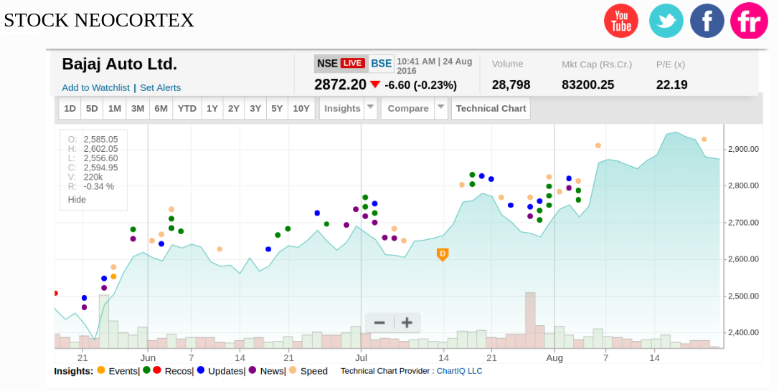

***Figure-2: neocortex chart***

### Hardware Interfaces

The existing Local Area Network (LAN) will be used for collecting data from the users and also for updating the Library Catalogue.

### Software Interfaces

A firewall will be used with the server to prevent unauthorized access to the system.

### Communications Interfaces

The Online Library System will be connected to the World Wide Web.

# Database Design

## System Diagram

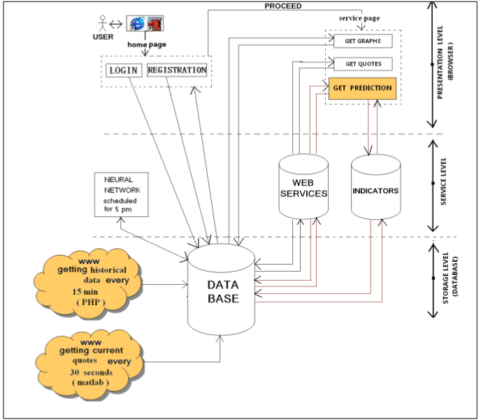

* **System description and general working:**

As shown in Fig: 3, the system under consideration has three levels: presentation level, services level and storage level. The user gives the input and gets the required output through the interface. The services level performs various actions on the input data according to the user’s demands and send the data back to the user. This level consists of Neocortex Network, Web Services and the indicators. The storage level lies in the bottom of the other levels and has the database that store and records the entire data. The user is provided with the “home page” when he opens the application. The user is asked to provide a correct combination of username and password. This pair of username and password is sent to the database for verification. If the combination is correct, the user is directed to the “service page”. If the user is new to the system then he is allowed to register as a new user. The user selects the “registration” button and is then allowed to fill in the registration form, when this is done, the corresponding information is sent and stored into the database and the user has now got the username and password to login into the system.

There are three key options that a user can select according to his requirement. These are:

• Get Quote (to get the quotes for a selected stock)

• Get Graphs (to get the graphs for a selected stock)

• Get Prediction (to get the prediction for a selected stock).

Once the user enters the home page, he can select a stock from the drop down list and then select one of these options accordingly.if a user wants to see the graph of a particular stock, the information is directly sent to the database, corresponding data is fetched, required actions are performed on it and the required graph is sent back to the top layer that is the interface. If the user wants to get the quotes of a particular stock, he selects that stock and clicks the “quotes” button. In this case the Web Service is called which takes the data from the data base, performs the required actions and send the required data to the user. If the user wants to get the prediction of a stock, the user again selects the stock from the list,clicks the “Prediction” button. There are two ways in which the system works: one is using the Web Services and the other one is using the Indicators which can be invoked by the user.

Based on the method selected (Web Services or the Indicators), data is again fetched from the database and the desired results are sent back to the user through the services level.

The database is kept up to date with the latest data and this data is inserted into the database every 15 minutes using the internet resources. After every 15 minutes, new data is inserted intothe database and the old one is removed. Google stocks (http://finance.google.com) are being used for fetching the data for our system and the programming code keeps on updating the database periodically.

## Table Structures

**user**

|  |  |  |  |
| --- | --- | --- | --- |
| **Column name** | **Type** | **Length** | **Remarks** |
| uname | Varchar | 20 | PK |
| pass | Varchar | 20 | NOT NULL |
| emailed | Varchar | 50 |  |
| name | Varchar | 50 |  |
| is_valid | tinyint | 1 |  |
| authority | number | 1 | NOT NULL |
| is_reset | tinyint | 1 |  |
| url_photo | varchar | 50 |  |
| mobile_no | varchar | 13 | NOT NULL |

**Scrapednews**

|  |  |  |  |
| --- | --- | --- | --- |
| News_id | Varchar | 20 | Not null |
| date | date |  | Not null |
| news_title | Varchar | 50 | Not null |
| news_desc | Varchar | 100 | Not null |
| analysis | Varchar | 40 | Not null |
| include_stock | Varchar | 40 | Not null |
| link | Varchar | 80 | Not null |

**log**

|  |  |  |  |
| --- | --- | --- | --- |
| **Column name** | **Type** | **Length** | **Remarks** |
| inserted_by | Varchar | 20 | FK users.uname |
| log_desc | varchar | 20 |  |
| timestamp | varchar | 20 |  |

# Non-Functional Requirements

## Performance

### Response Time

The Information page should be able to be downloaded within a minute. The information is refreshed every two minutes. The access time for a device should be less than a minute. The system shall respond to the member in less than two seconds from the time of the request submittal. The system shall be allowed to take more time when doing large processing jobs.

### Throughput

The number of transactions is directly dependent on the number of users;

### Capacity

The system is capable of handling 250 users at a time(It depends on server).

### Resource Utilization

The resources are modified according the user .

## Reliability

The system has to be very reliable due to the importance of data and the damages incorrect or incomplete data can do.

### Availability

The system is available 100% for the user and is used 24 hrs a day and 365 days a year. The system shall be operational 24 hours a day and 7 days a week.

### Mean Time Between Failures (MTBF)

The system will be developed in such a way that it ***may*** fail once in a year.

### Mean Time to Repair (MTTR)

Even if the system fails, the system will be recovered back up within an 5 min.

### Accuracy

The accuracy of the system is limited by the accuracy of the speed at which the users use the system.

### Maximum Bugs or Defect Rate

Not specified.

### Access Reliability

The system shall provide 100% access reliability.

## Usability

* The system shall allow the users to access the system from the Internet using HTML or its derivative technologies. The system uses a web browser as an interface.
* Since all users are familiar with the general usage of browsers, no specific training is required.
* The system is user friendly and self-explanatory